**PRACTICAL – 7**

**Q. Write a program to use IR ( Infrared ) Sensor to Respberry Pi .**

**Hardware:-**

* Raspberry pi
* Infrared Sensor (IR)
* LED
* 10k ohm potentiometer
* Breadboard and wires

**IR Sensor Module:**

**IR sensors (Infrared sensor)** are modules which detect the presence of objects before them. If the object is present it give 3.3V as output and if it is not present it gives 0 volt. This is made possible by using a pair of **IR pair** (transmitter and receiver), the **transmitter (IR LED)** will emit an IR ray which will get reflected if there is a object present before it. This IR ray will be received back by the **receiver (Photodiode)** and the output will be made high after amplified using an op-amp link **LM358**. You can learn more about [IR Sensor Module Circuit](https://circuitdigest.com/electronic-circuits/ir-sensor-circuit-diagram) here.

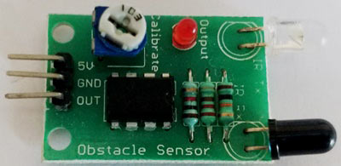IR Sensor Module

The IR Sensor used in this project is shown above. Like all IR sensor it has three pins which are 5V, Gnd and Out respectively. The module is powered by the 5V pin from Raspberry Pi and the out pin is connected to GPIO14 of Raspberry Pi. The potentiometer on top of the module can be used to adjust the range of the IR sensor.

**Circuit Diagram and Explanation:**

The circuit diagram for **connecting Raspberry Pi with IR sensor** is shown below. As you can see the circuit diagram is very simple. We have directly powered the IR module from the 5V and Ground Pin of Raspberry Pi. The output pin of the IR module is connected to the GPIO14. We have also used two LED (Green and Red) to indicate the status of the object. These two LEDs are connected to GPIO3 and GPIO2 respectively.

[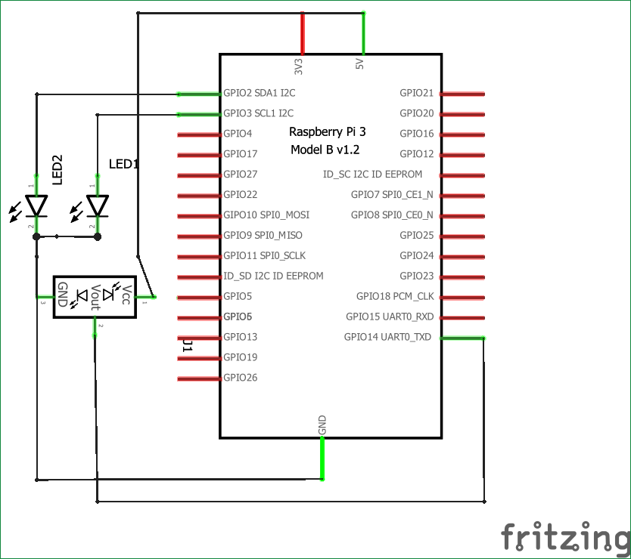](https://circuitdigest.com/fullimage?i=circuitdiagram_mic/IR-sensor-interfacing-with-raspberry-pi-circuit-diagram.png)

Since the GPIO pins of Raspberry Pi are 3.3V, a current limiting resistor is not mandatory. However if desired a resistor of value 470 ohms can be added between the ground pin of LEDs and Raspberry Pi. The whole circuit is powered by a 5V mobile charger through the micro USB port of the Raspberry pi.

**Code:-**

import RPi.GPIO as IO  
import time  
IO.setwarnings(False)  
IO.setmode(IO.BCM)

IO.setup(2,IO.OUT) #GPIO 2 -> Red LED as output  
IO.setup(3,IO.OUT) #GPIO 3 -> Green LED as output  
IO.setup(14,IO.IN) #GPIO 14 -> IR sensor as input

while 1:

    if(IO.input(14)==True): #object is far away  
        IO.output(2,True) #Red led ON  
        IO.output(3,False) # Green led OFF  
      
    if(IO.input(14)==False): #object is near  
        IO.output(3,True) #Green led ON  
        IO.output(2,False) # Red led OFF

**OutPut:-**

